Unit 4 Lesson 2

Date: 2023-10-08

Project: Rock Paper Scissors

Done: Understand what I must do

To do: create a flowchart and pseudocode for determining win, loss and tie and implement it into python.

Flowchart:

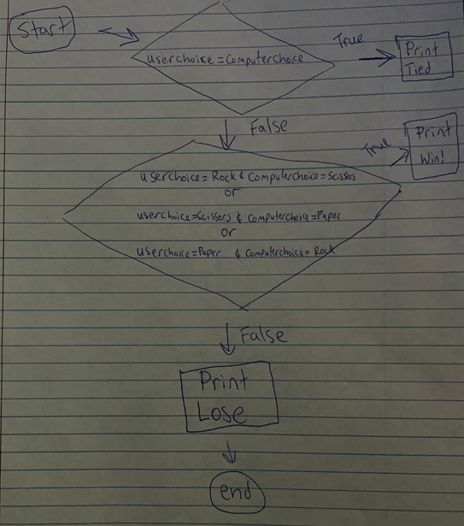

Pseudocode:

RPS = ['Rock', 'Paper', 'Scissors']

WHILE True

user_choice = input("").capitalize()

IF user_choice in RPS

RETURN

ELSE

WRITE "ERROR"

computer_choice = random.choice(RPS)

RETURN computer_choice

WHILE True

user_choice = userChoice()

computer_choice = computerChoice()

WRITE "you chose {user_choice} computer chose {computer_choice}"

IF user_choice = computer_choice

WRITE "you tied"

ELSE

IF (user_choice = 'Rock' AND computer_choice = 'Scissors') OR (user_choice = 'Scissors' AND computer_choice = 'Paper') OR (user_choice = 'Paper' AND computer_choice = 'Rock')

WRITE "You Win"

ELSE

WRITE "You Lose"

I learned throughout this lesson how to use pseudocode to brainstorm my code and all of its functions before implementing it into python. I feel like I completed this assignment of creating rock paper scissors with ease without any major issues.